https://www.facebook.com/profile.php?id=100065228971709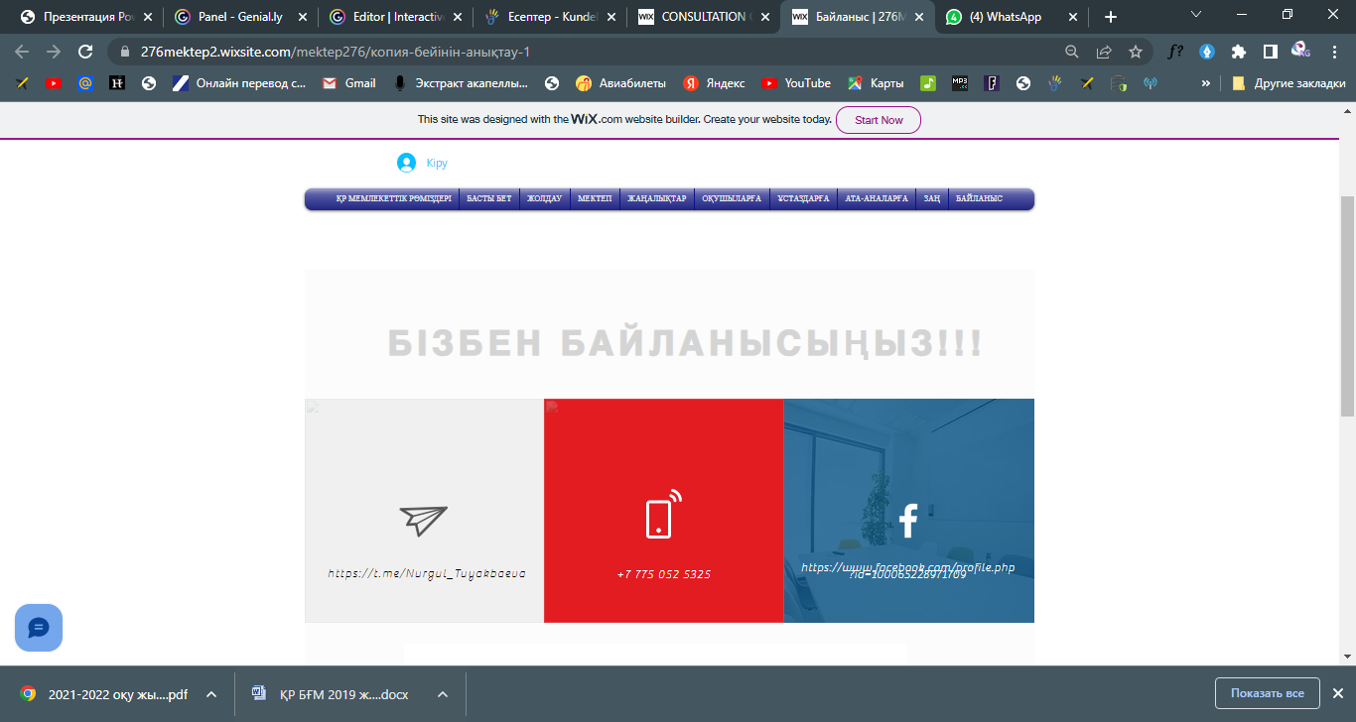

https://www.facebook.com/profile.php?id=100065228971709

https://t.me/Nurgul_Tuyakbaeva